EU DECLARATION OF CONFORMITY Number: (1)
- PPE: (Product, Type, batch or serial number) KNEE PAD, DF016-01
- Name and address of the manufacturer and where applicable his authorised representative:
Hangzhou Dafang Tools Co., Ltd.
No.8 Wanda North Road, Huangshan Village Park, Wenyan Town, Xiaoshan, Hangzhou, Zhejiang, China
- This declaration of conformity is issued under the sole responsibility of the manufacturer: Hangzhou Dafang Tools Co., Ltd.
- ___insert description of the object of declaration. (identification of PPE allowing traceability; where necessary for the identification of the PPE a colour image of sufficient clarity may be included) ______.
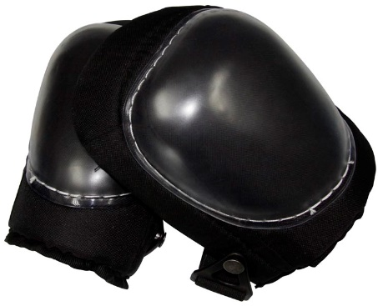
- The object of the declaration descried in point 4 is in conformity with the relevant Union harmonisation legislation: Regulation (EU) 2016/425
- References to the relevant harmonised standards used, including the date of the standard or references to the other technical specification, including the date of the specification, in relation to which conformity is declared: EN 14404: 2004 + A1: 2010
- Where applicable, the notified body n° 2777 SATRA Technology Europe Ltd performed the EU examination (Module B) and issued the EU type- examination certificate (Reference to that certificate).
- Where applicable, the PPE is subject to the conformity assessment procedure. (either conformity to type based on internal production control plus supervised product checks at random intervals (module C2) or conformity to type based on quality assurance of the production process (module D) ... under surveillance of the notified body ... (name, Number)
- Additional information
Signed for and on behalf of Hangzhou Dafang Tools Co., Ltd.
Place: Hangzhou, China Date of issue: 2020-4-21
Name: Position: Quality Manager
Signature:
- It is optional for the manufacturer to assign a number to the declaration of conformity.

